**DAY5_AWS_AUTOSCALING**

DAY5_AWS_AUTOSCALING_CE1

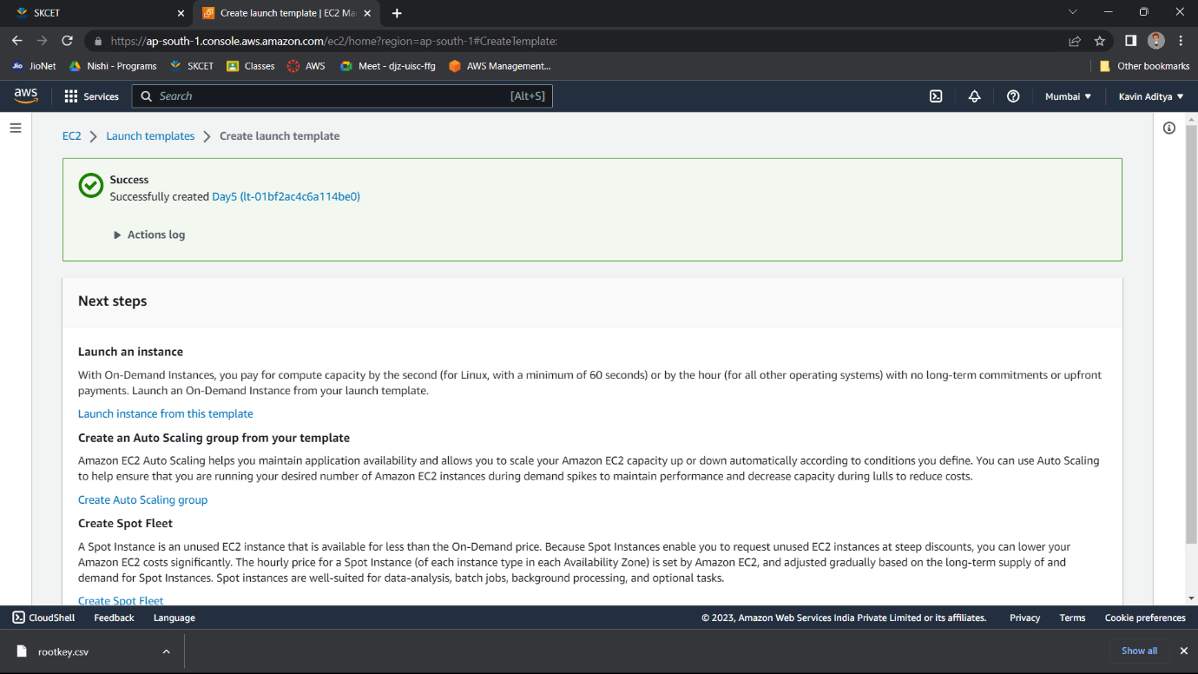

DAY5_AWS_AUTOSCALING_CE2

